**Exercise 1: Creating a Linux Virtual Machine in Microsoft Azure**

In this exercise, you will learn how to provision a Linux Virtual Machine in the Azure portal.

**Task 1 - Creating a New Linux Virtual Machine**

1. Open Internet Explorer and browse [https://manage.windowsazure.com](https://manage.windowsazure.com/) to enter the Microsoft Azure portal. Then, log in with your credentials.
2. In the menu located at the bottom, select **Compute** | **New Virtual Machine | From Gallery** to start creating a new virtual machine.

[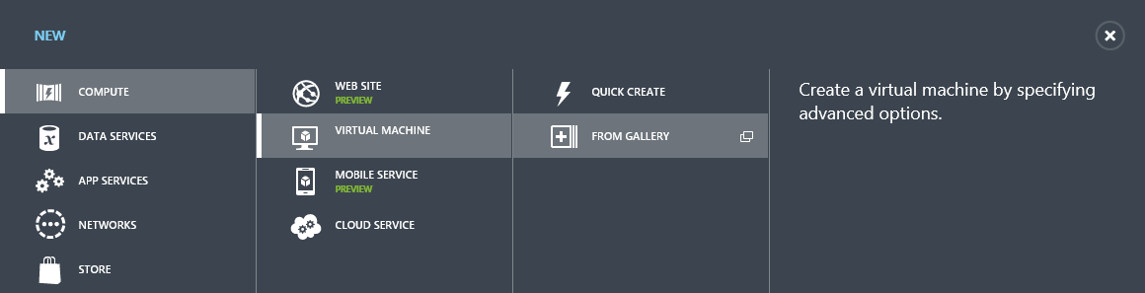](https://github.com/Azure-Readiness/MicrosoftAzureTrainingKit/blob/master/HOLs/HOL-IntroToWindowsAzureVirtualMachinesLinux/Images/creating-a-new-virtual-machine.png?raw=true)

*Creating a new Virtual Machine*

1. In the **Virtual Machine operating system selection** page, click **Platform Images** on the left menu and select the **openSUSE** OS image from the list. Click the arrow to continue.

[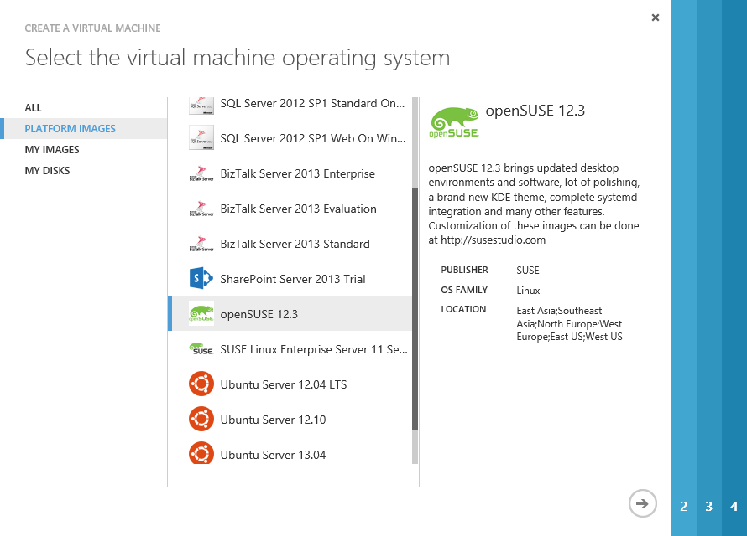](https://github.com/Azure-Readiness/MicrosoftAzureTrainingKit/blob/master/HOLs/HOL-IntroToWindowsAzureVirtualMachinesLinux/Images/creating-a-vm-suse.png?raw=true)

*Selecting openSUSE from the image list*

1. In the **Virtual Machine Configuration** page, enter a **Virtual Machine Name**. In the **Authentication** section, uncheck **Upload compatible ssh key for authentication** and check **Provide password**. Provide a password for the **New Password** and **Confirm Password** fields. Lastly, set the Virtual Machine **Size** to *Small* and click **Next** to continue.

[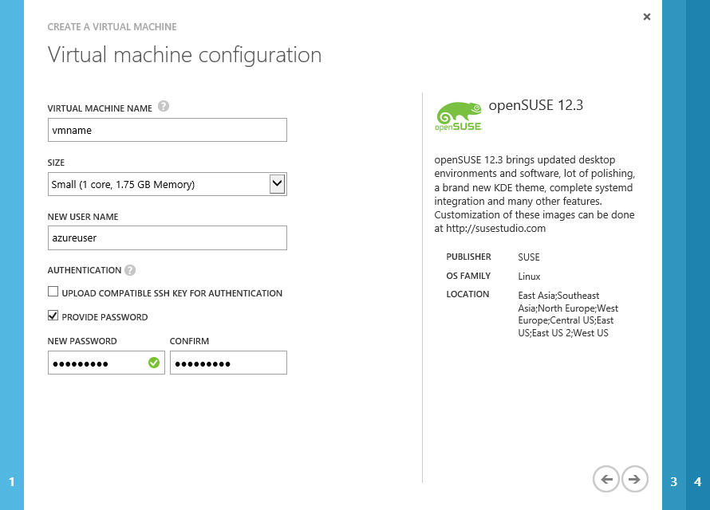](https://github.com/Azure-Readiness/MicrosoftAzureTrainingKit/blob/master/HOLs/HOL-IntroToWindowsAzureVirtualMachinesLinux/Images/creating-a-vm-configuration.png?raw=true)

*Creating a Virtual Machine - Configuration*

**Note:** It is suggested to use secure passwords for admin users, as Microsoft Azure virtual machines could be accessible from the Internet knowing just their DNS.

You can also read this document on the Microsoft Security website that will help you select a secure password:<http://www.microsoft.com/security/online-privacy/passwords-create.aspx>

1. In the **Virtual Machine Mode** page, select **Standalone Virtual Machine**, enter the **DNS Name**, you can automatically generate a new Storage Account or select one you already own. Then, select the **Region/Affinity group/Virtual Network** value and select the **subscription**. Click the **right arrow** to continue.

[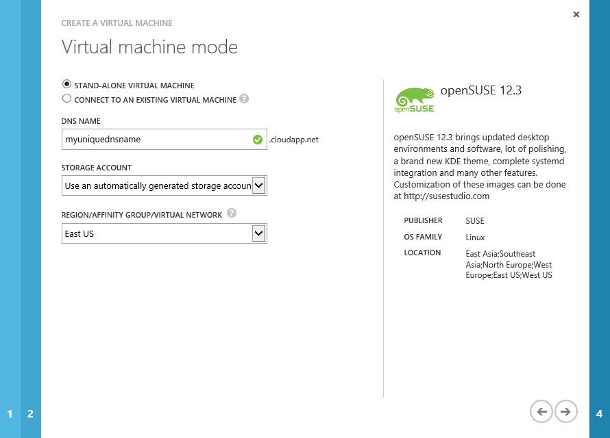](https://github.com/Azure-Readiness/MicrosoftAzureTrainingKit/blob/master/HOLs/HOL-IntroToWindowsAzureVirtualMachinesLinux/Images/creating-a-vm-vm-mode.png?raw=true)

*Creating a Virtual Machine - Virtual Machine Mode*

1. In the **Virtual Machine Options** page, click the button to create a new Virtual Machine.

[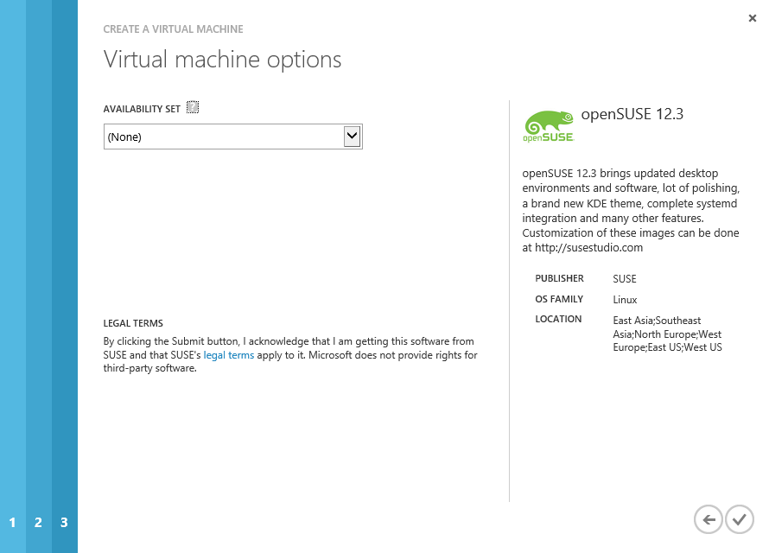](https://github.com/Azure-Readiness/MicrosoftAzureTrainingKit/blob/master/HOLs/HOL-IntroToWindowsAzureVirtualMachinesLinux/Images/creating-a-vm--vm-options.png?raw=true)

*Creating a Virtual Machine - Virtual Machine Options*

1. In the **Virtual Machines** section, you will see the Virtual Machine you created with a *provisioning* status. Wait until it changes to *Running* in order to continue with the following step.

[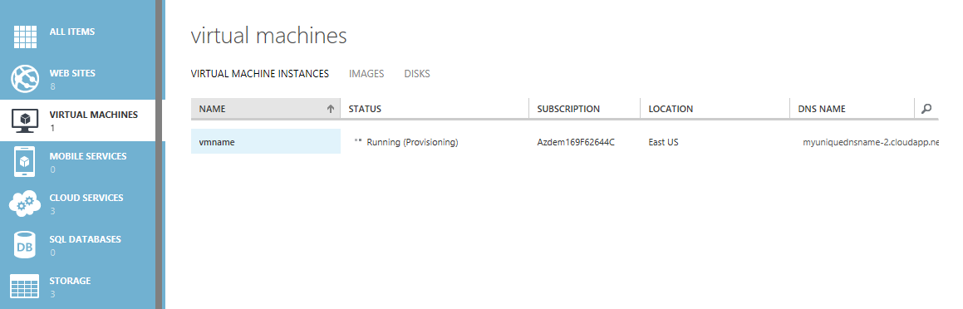](https://github.com/Azure-Readiness/MicrosoftAzureTrainingKit/blob/master/HOLs/HOL-IntroToWindowsAzureVirtualMachinesLinux/Images/creating-linux-vm.png?raw=true)

*Creating Linux Virtual Machine*

1. Now, you will create the endpoints required to manage the Virtual Machine. To do this, select the Virtual Machine to go to the **Dashboard** page and then click **Endpoints**.
2. Click **Add Endpoint**, select **Add Endpoint** option and then click the **right arrow** to continue.

[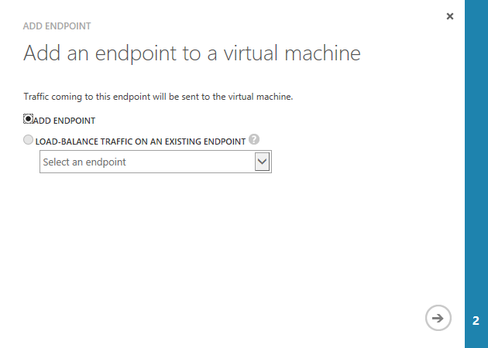](https://github.com/Azure-Readiness/MicrosoftAzureTrainingKit/blob/master/HOLs/HOL-IntroToWindowsAzureVirtualMachinesLinux/Images/adding-a-new-endpoint.png?raw=true)

*Adding a new Endpoint*

1. In the **Specify the details of the endpoint** page, set the **Name** to *webport*, the **Protocol** to *TCP* and the **Public Port** and **Private Port** to *80*.

[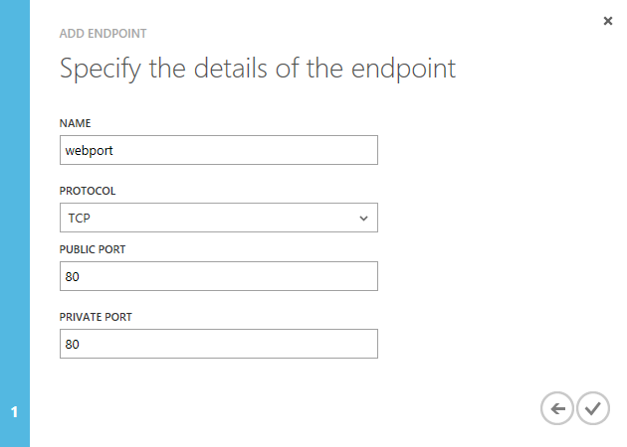](https://github.com/Azure-Readiness/MicrosoftAzureTrainingKit/blob/master/HOLs/HOL-IntroToWindowsAzureVirtualMachinesLinux/Images/new-endpoint-details.png?raw=true)

*Specify Endpoint Details*

**Note:** This endpoint enables the port 80 that will be used by the Apache Server in the following tasks

**Task 2 - Verification: Connecting to the Virtual Machine by using a SSH client**

Now that you have provisioned and configured a Linux Virtual Machine, you will connect by using an SSH client.

**Note:** You can download Putty, a free SSH client for Windows, here: <http://www.putty.org/>

1. In the Microsoft Azure Portal, select the Linux Virtual Machine from the list to enter the **Dashboard**. Take note of the**SSH Details** field at the "quick glance" section, which is the public address you will use to access and connect to the virtual machine using the SSH client.

[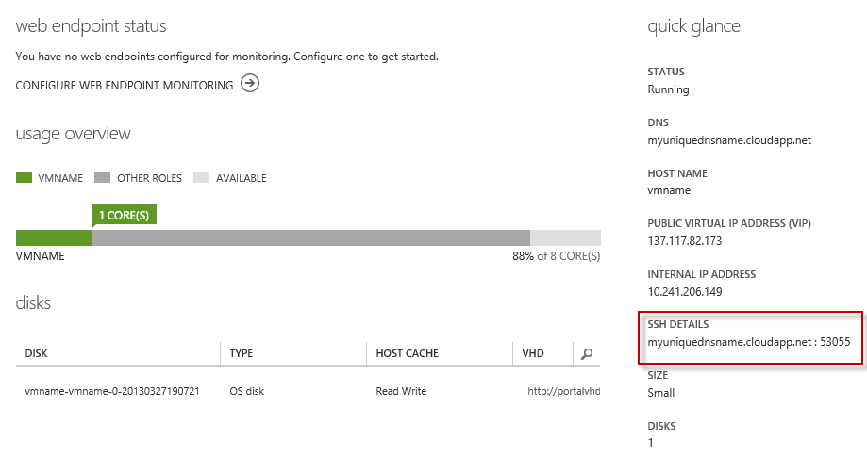](https://github.com/Azure-Readiness/MicrosoftAzureTrainingKit/blob/master/HOLs/HOL-IntroToWindowsAzureVirtualMachinesLinux/Images/ssh-endpoint.png?raw=true)

*SSH Endpoint*

1. Open the Putty client (or any other SSH client) and create a new connection to the Virtual Machine, using address and port from the previous step.

[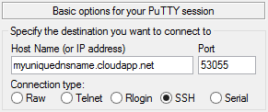](https://github.com/Azure-Readiness/MicrosoftAzureTrainingKit/blob/master/HOLs/HOL-IntroToWindowsAzureVirtualMachinesLinux/Images/connecting-to-the-linux-vm-via-putty-client.png?raw=true)

*Connecting to the Linux Virtual Machine via Putty Client*

**Note:** You can verify the public port for the SSH connection in the **Endpoints** section of the Virtual Machine. When using Putty, make sure you enable TCP Keepalives and set it with a value greater than 5.

1. Use the Virtual Machine credentials to login.

**Note:** When completing the password, the cursor won't move

[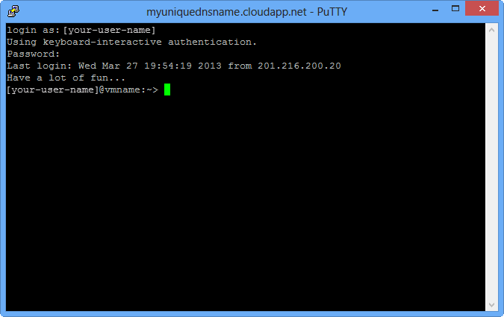](https://github.com/Azure-Readiness/MicrosoftAzureTrainingKit/blob/master/HOLs/HOL-IntroToWindowsAzureVirtualMachinesLinux/Images/logging-in-to-the-linux-virtual-machine.png?raw=true)

*Logging in to the Linux Virtual Machine*

1. Execute the following command to impersonate with **Administrator** rights.
2. sudo su -

[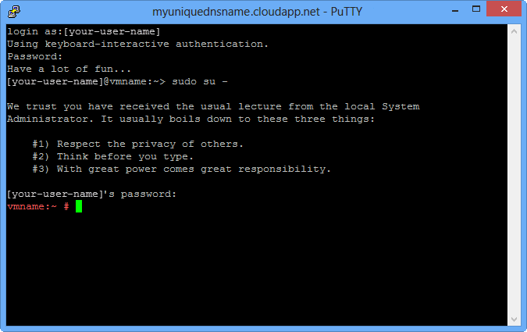](https://github.com/Azure-Readiness/MicrosoftAzureTrainingKit/blob/master/HOLs/HOL-IntroToWindowsAzureVirtualMachinesLinux/Images/logging-in-with-administrator-rights.png?raw=true)

*Logging in with Administrator rights*